***Practical 5:-Sharding using Mongodb***

***Name :- SK TARANNUM***

***Roll no :- 35***

# Step 1 :-

***create c:\data\db folders otherwise mongo will generate error at startup***

# STEP 2:-

***create other folders for replica set like c:\data\db1 and db2***

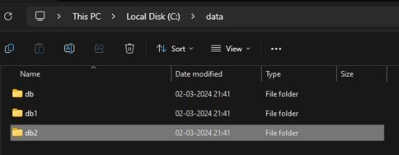

# STEP 3:-

***Go to mongodb default folder location and find mongod.conf file windows default: C:\Program Files\MongoDB\Server\7.0\data open file in edit mode and find replication: remove # from `replication` and in the next line add***

***``` cmd replication:***

***replSetName: "your_replica_set_name“***

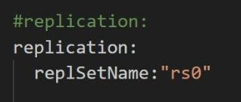

# Step 4 :-

***open cmd for each replication folder like db, db1, db2 and so on...***

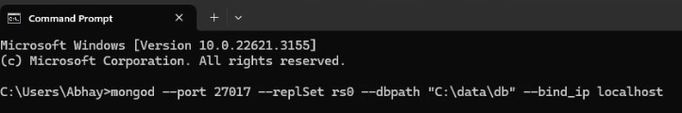

# STEP 5:-

***create other folders for replica set like c:\data\db1 and db2***

***type the following command to execute each replica node***

***Cmd > mongod --port 27017 --replSet your_replica_set_name --dbpath***

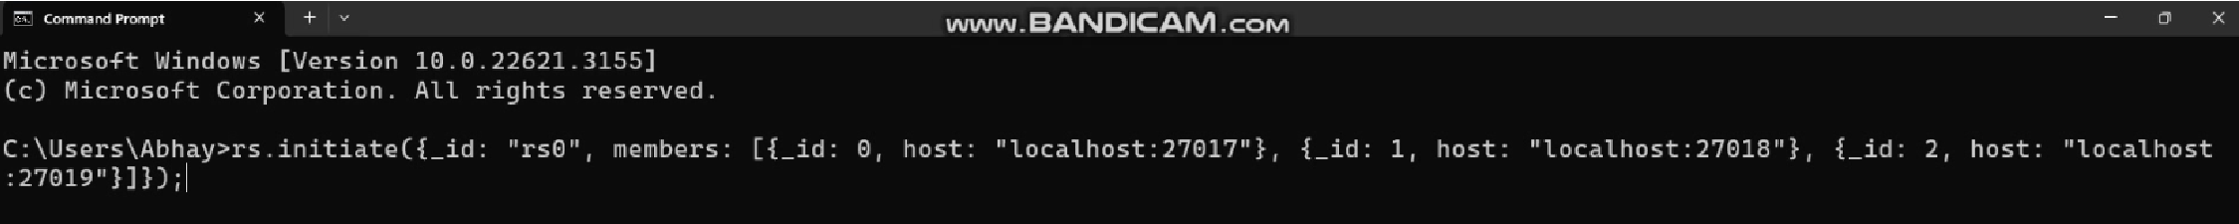***"C:\data\db" --bind_ip localhost***

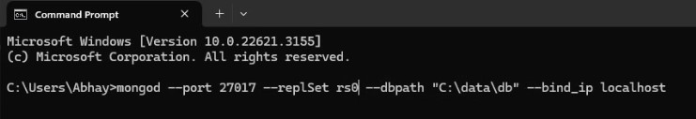

***repeat above step for all other replica set node with diffrenet ports like 27018, 27019 and so on and db folder names like db1, db2 and so on***

# STEP 6:-

***initiate the settings to add members to replica set cmd***

***rs.initiate({_id: "rs0", members: [{_id: 0, host: "localhost:27017"}, {_id: 1, host: "localhost:27018"}, {_id: 2, host: "localhost:27019"}]});***

# Step 7 :-

***check the status cmd> rs.status()***

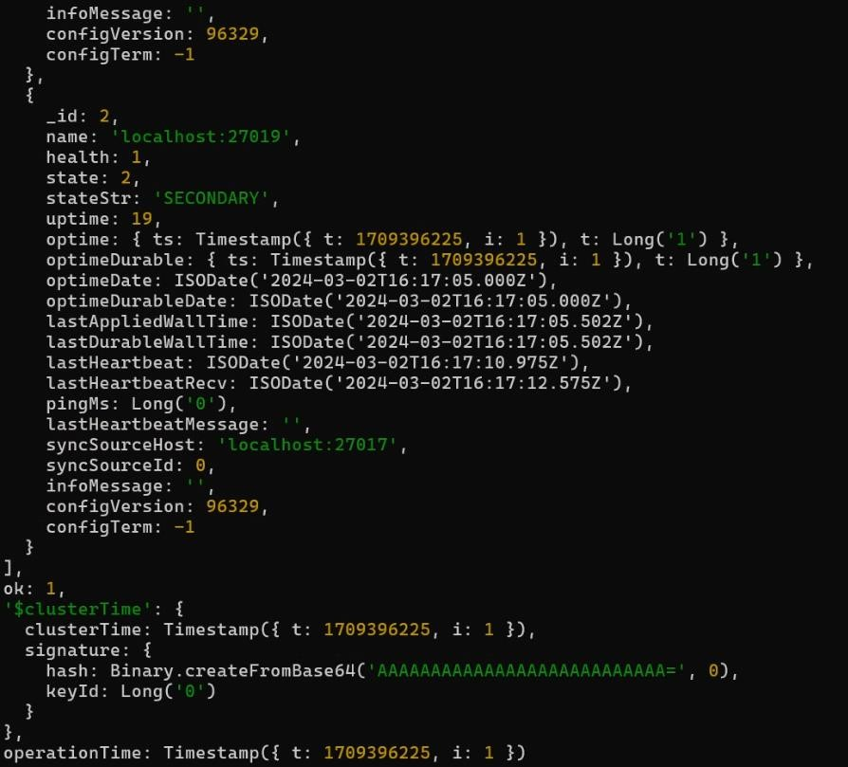

# STEP 8:-

***check the status cmd> rs.conf()***

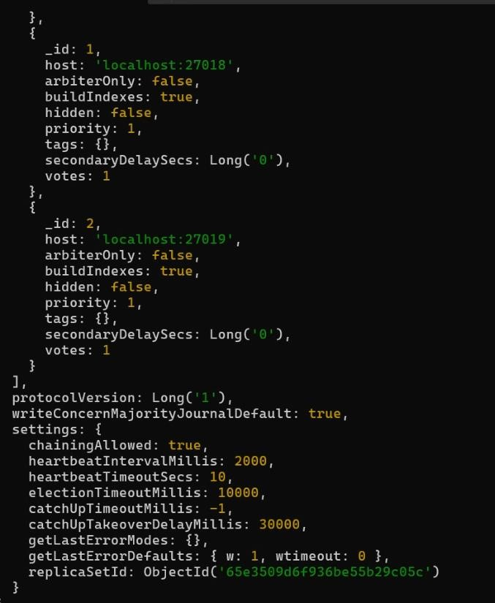

# Step 9 :-

***now you can add more member using***

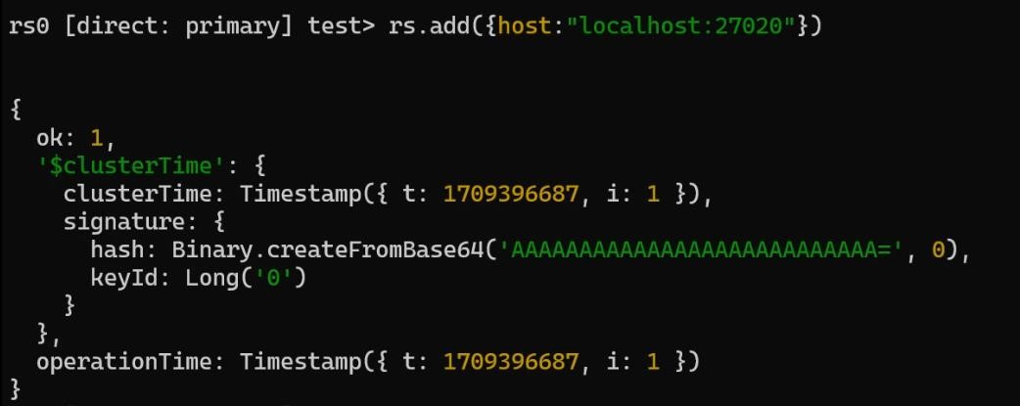

# STEP 10:-

***remove memeber from replication set***

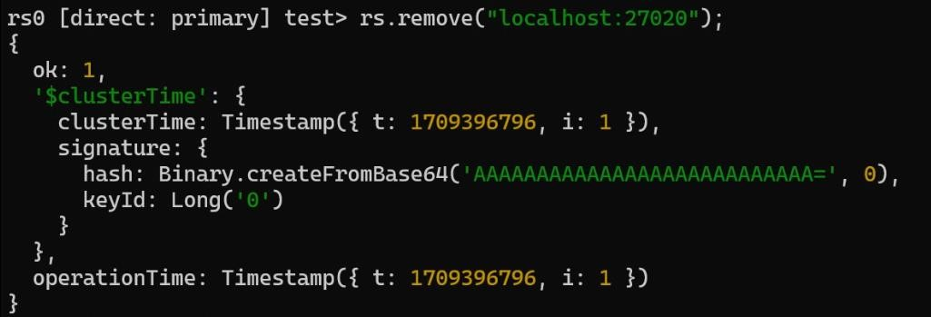

***--------------- WARNINGS -----------------if you stepdown primary using:***

***`rs.stepDown()`***

***then use below command to check configuration and set primary back***

***`rs.conf()`***

***you can set previliges for primary and secondary `db.getMongo().setReadPref('primaryPreferred')` and when you on secondary node `db.getMongo().setReadPref('secondary')`***

***# REMOVING OF REPLICA SETS***

***_stop mongodb all running instances***

***_comment back the `replSetName` and `replication` in `mongod.conf` file***

***_now start an instance using simple command***

***``` cmd***

***mongod --port 27017 --dbpath "path to db folder"***

***```***

***# RECONFIG MEMBERS USING rs.initiate();***

***_remove all secondary nodes and then type:***

***``` cmd***

***db.adminCommand({ replSetStepDown: 120, force: true })***

***```***

***_this will step down the primary node***

***# RECONFIG THE CONFIGURATION***

***``` cmd rs.reconfig({***

***_id: "your_replica_set_name", members: [***

***{ _id: 0, host: "localhost:27017" },***

***// Add other members here if needed***

***]***

***}, { force: true }); ```***

***NOTE: if you want now you can delete all other files if the testing is completed.***